Islamic Prayer Times Determined from Geodetic Astronomic Principles

Eng. Doha Amr  Demonstrator, Faculty of Engineering, Shoubra  Benha University | Prof. Dr. Saad Bolbol  Professor, Faculty of Engineering, Shoubra  Benha University
Dr. Karim S. Rashwan  Lecturer, Faculty of Engineering, Shoubra  Benha University | Eng. R. Fekry  Demonstrator, Faculty of Engineering, Shoubra  Benha University

Abstract
Technological advancements witnessed in the past decade have facilitated the computation of many previously complex calculations. As a result, it is now convenient to calculate prayer times at any given location. In every Islamic country, there is an organization which calculates prayer times for every single day of the year and publishes it in its calendar. Nowadays, it is easy for an ordinary person to locate their position via GPS on their mobile phones, this facilitates the calculation of prayer times according to the location of the indicated person. This paper introduces new methods of calculations that can be carried out in order to determine prayer times at any given location.

- Introduction
According to the Islamic faith, Muslims are required to perform five prayers per day. Each prayer time is defined in accordance with the sun’s movement. The sun’s movements change every day according to its ecliptic which is differently measured according to the perspective of prayer’s location on earth (latitude and longitude of the prayer). Calculation of prayer times in any given city is calculated based on the city’s mean latitude and longitude and is measured to the nearest minute of times.
Many attempts have been published calculating prayer times, however such calculations are not simple and some may not even on the basis of the science of geodetic astronomy. This paper gives simple and logical equations that depend on the principles of spherical astronomical triangle and the time taken for the movements of the sun.
The calculations depend on three factors, namely; 1) the mean latitude and longitude of the city or area of interest, 2) the declination of the sun on the day of calculation (as prayer times are different each day due to the change in the declination of the sun everyday (Ecliptic)), and 3) the Equation of Time which is the difference between the apparent sun and the fictitious sun.
The following table defines prayer times describing the phases of sun’s light for each prayer time:
Prayer | Defined Time
Fajr | Dawn, when the first appearance of light becomes visible in the sky before sunrise
Sunrise | The time at which the sun first touches the horizon
Dhuhr | The highest position of the sun in the sky during its journey from sunrise to sunset. This is when the shadow of a vertically erected stick is at its shortest all day. In other words, this is the time when the sun is on the meridian of the prayer.
Asr | The calculation of this prayer is debatable. Some calculate it as the time at which the shadow of a vertically erected stick is equal to the length of the shadow at Dhuhr prayer plus the length of the stick itself, while others calculate it as the time at which the shadow of a vertically erected stick is equal to the length of the shadow at Dhuhr prayer plus twice the length of the stick itself.
Sunset, Maghrib | The time at which the last apparent part of the sun disappears below the horizon.
Isha | The time at which darkness falls and there is no scattered light in the sky, i.e. time taken by the sun’s movement by a defined angle under the sunset.

- Methodology

The calculations of prayer times mostly depend on the position of the prayer and the sun’s movements. The data required for such calculations are as follows:
- Mean latitude and longitude of the area of interest.
- Declination of the sun on the day of calculation (δsun).
- Equation of Time on the day of calculations (EoT).
The calculations start with the determination of the Dhuhr prayer first then sunrise and sunset that lead to calculations of Fajr and Isha. For the Asr prayer, the calculation mentioned in the table above are not accurate relative to the calculations of the Egyptian Surveying Authority (ESA) published every year in the calendar.
With respect to Fajr and Isha prayers calculations, the angle achieved by the sun below the horizon (the time which the sun’s light is believed to be completely disappearing) differs from a place to another. The following table shows these angles in different areas changed according to the clearance of the weather in that area.
Table (1)
Several conventions for calculating Fajr and Isha currently in use in various countries:
Convention | Fajr Angle | Isha Angle
Leva Research Institute, Qom, Iran* | 16 | 14
University of Islamic Sciences, Karachi | 18 | 18
Islamic Society of North America (ISNA), USA | 15 | 15
Muslim World League (MWL) | 18 | 17
Umm al-Qura, Makkah, Saudi Arabia | 19 | 90 mins after Maghrib
Egyptian General Authority of Survey | 19.5 | 17.5

- Calculations

  - Dhuhr
Dhuhr = 12^{h} + Time Zone –Long/15 – EOT
The two terms representing the time zone and the longitude of city of interest are presented here because the EOT is obtained for 0 hrs UTC.
  - Sunrise and Sunset
At sunrise the sun passes through the horizon of the observer which means that the zenith of the Sun equals 90◦, by solving the astronomical triangle at this case by Nabir’s rule, the hour angle of the sun (the time elapsed from/ before transit to sunset/sunrise) can be calculated as follow:

$$\cos{t=-\tan{δ}\tan{φ}}$$

Sunrise = noon corrected by equation of time (Dhuhr) – t (in hours)
Sunset = noon corrected by equation of time (Dhuhr) + t (in hours)
  - Fajr and Isha
The angle of Sun under the horizon used for calculating Fajr and Isha differs from country to another according to the institution responsible for determining the prayer times. From this angle, the zenith of sun can be obtained and the sun hour angle (t) from the solution of astronomical triangle.

Fajr = noon corrected by equation of time (Dhuhr) – t (in hours)
Isha = noon corrected by equation of time (Dhuhr) + t (in hours)
  - ASR
Asr time is when the length of a vertical stick shadow equals the stick length plus its shadow length at Duhr prayer

- Application

For Cairo 20th April 2015
Φ = 30◦ 03̍ N , δ = 11◦ 19̍ 51.1̎
ʎ = 31◦ 14̍ E , EOT = 55.51̎

  - Dhuhr
Dhuhr = 12^{h} + Time Zone –Long/15 – EOT
Dhuhr = 12 + 2^{h} – 2^{h} 5^{m} – 55.51̎ /3600 = 11^{h} 54^{m} 4.49^{s}
  - Sunrise and Sunset

$$\cos{t=-\tan{δ}\tan{φ}}$$
t = - tan 11◦ 19̍ 51.1̎ tan 30◦ 3̍
t = 96◦ 39̍ 24.65̎ ……… ( */ 15)
t = 6^{h} 26^{m} 37.64^{s}
Sunrise = corrected noon – t
Sunrise = 11^{h} 54^{m} 4.49^{s} – 6^{h} 26^{m} 37.64^{s}
Sunrise = 5^{h} 27^{m} 26.85^{s}
Sunset = corrected noon + t
Sunset = 11^{h} 54^{m} 4.49^{s} + 6^{h} 26^{m} 37.64^{s}
Sunset = 18^{h} 20^{m} 42.13^{s}
  - Asr
The length of stick taken is 1 meter and length of its shadow equals 1.50 meters.
Tan z = (length of stick’s shadow / length of stick)
Tan z = 1.50 / 1 m
Z = 56◦ 18̍ 35.76̎
By solving the astronomical triangle:
$$\cos{t}=\frac{cos z{-\cos\left(90-δ\right)\cos{(90- φ)}}}{\sin\left(90-δ\right)\sin{(90- φ)}}$$

t = 58◦ 10̍ 32.87̎ …….( * / 15)

t = 3^{h} 52^{m} 42.19^{s}
Asr = Dhuhr + t

= Dhuhr + 3^{h} 52^{m} 42.19^{s} = 15^{h} 46^{m} 46.68^{s}

  - Fajr and Isha
When the sun under the horizon is taken at 18◦, and the zenith angle is equals to 108◦, by solving the same previous astronomical triangle, we get:
Cos z = cos (90-δ) * cos (90-φ) + sin (90- δ)* sin(90-φ) * cos t
Cos 108◦ = cos (90 - 11◦ 19̍ 51.1̎) * cos (90-30◦ 03̍)+ sin (90 - 11◦ 19̍ 51.1̎) * sin (90-30◦ 03̍) * cos t
t = 118◦ 41̍ 12.48̎ …….. ( * / 15)
t = 7^{h} 54^{m} 44.83^{s}
Fajr = Dhuhr – t = 3^{h} 59^{m} 19.66^{s}
Isha = Dhuhr + t = 19^{h} 48^{m} 49.32^{s}
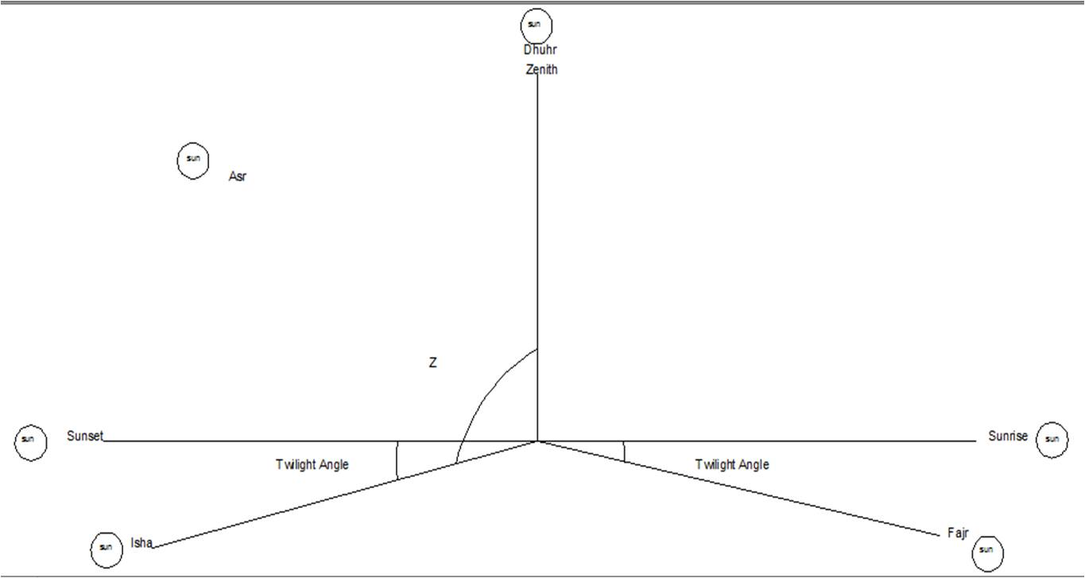
- Conclusion and Results Validation

The following table represents the difference between the computed values from the aforementioned method and the Egyptian Surveying Authority (ESA) prayer times

Time | ESA time | Computed Time | Difference
Dhuhr | 11^{h} 54^{m} | 1 ^{h} 54^{m} 4.49^{s} | 4.49^{s}
Sunrise | 5^{h} 23^{m} | 5 ^{h} 27 ^{m} 26.85^{s} | 4^{m} 26.85^{s}
Sunset | 6^{h} 25^{m} | 6 ^{h} 20 ^{m} 42.13^{s} | 5^{m} 42.13^{s}
Asr | 3 ^{h} 30^{m} | 3^{h} 46 ^{m} 46.68^{s} | 16^{m} 46.68^{s}
Fajr | 3 ^{h} 51^{m} | 3^{h} 59 ^{m} 19.66^{s} | 8^{m} 19.66^{s}
Isha | 7 ^{h} 47^{m} | 7^{h} 48 ^{m} 49.32^{s} | 1^{m} 49.32^{s}
For Asr:
If the difference is subtracted from the computed hour angle, the result will be:
t = 3^{h} 35^{m} 55.51^{s}
By solving the astronomical triangle for Z
z = 53◦ 57̍ 19.98̎
And thus
Tan Z = length of stick shadow / length of stick
Then, the length of shadow = 1.374 meters

References
- Prayer times for many countries
- Prayer Times Prayer times are calculated based location of the IP address.
- Prayer Times for more than 6 million cities in 252 countries in the world.
- Printable Prayer Times for more than 3.7 million cities in 200 countries in the world as well as latitude and longitude inputs.
- Salaah Time Reminders on Twitter for various Cities in South Africa
- Salat according to some Islamic schools of thought
- Prayer Times calculator based on city, address, postal code or latitude/longitude coordinates.
- PrayTime's Calculation - http://praytime.info/document.html

